1. Write an assertion to check clock period of 100 MHz.

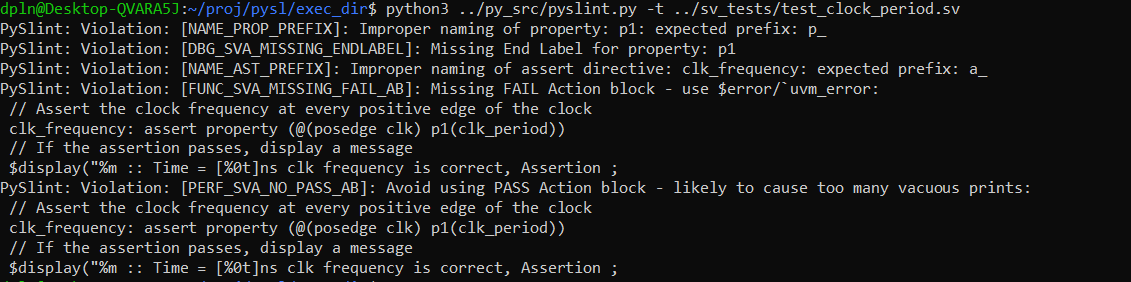

2. Write an assertion to check clock frequency and duty cycle with +/- 5% error.

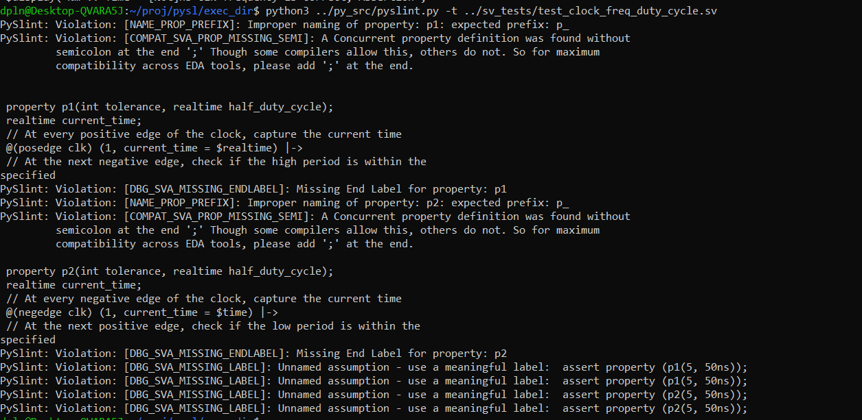

3. Write a constraint to generate unique values in rows for a multidimensional array.



4. Write a constraint to generate diagonal values should be same in a multidimensional array.



5. Write a constraint to generate an address where 9 bits are always set to 1, and sequences of 111 or 000 should not occur in a 16-bit address.



6. Write a Constraint to generate patterns 5,-10,15,-20,25....



7. Write a constraint to generate an address for different ports like port_0, port_1, port_2 and each Port is having starting and ending Address.

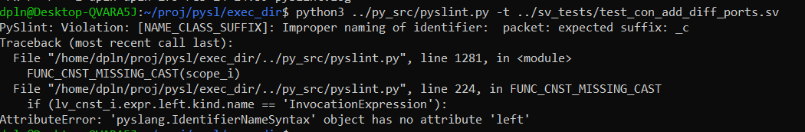

8. Write a constraint to generate a pattern 9,99,999,9999,99999,..



9. Write a constraint to generate the Fibonacci series.

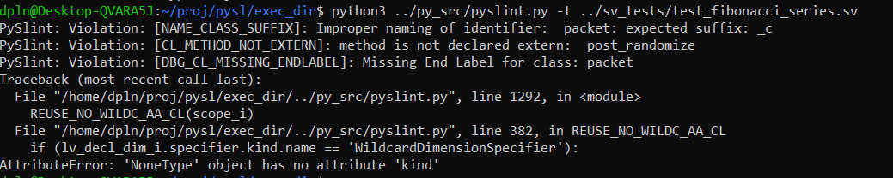

10. Write a constraint to generate palindrome.



11. Write a constraint to generate Prime numbers in different ways.

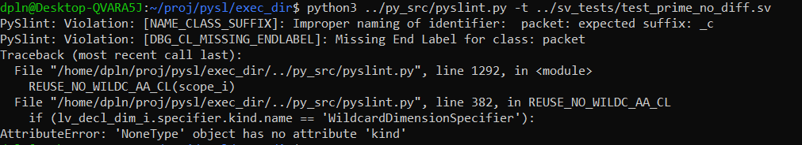

11.1. Write a constraint to generate Prime numbers in different way (another method).



12. Write a constraint to randomly generate 10 unique prime numbers in an array between 1 and 200 & generated prime numbers should have 7 in unit Place (eg :7,17,37....)

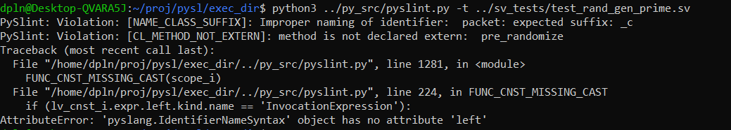

13. Write a constraint to implement randc construct using rand keyword.



14. There is a memory which can take addresses 0x00 to 0x100 except the reserved memory from 0x20 to 0xE0. address should not take reserved memory. address should be 4 byt aligned memory . Write constraint to generate 16 byte addresses. For example if it generates 0x0 now it should generate 0x4 ,next 0x8 next 0x12 addresses such that it generates 16byte addresses.



15. Write a constraint to generate a pattern of 0011223344...

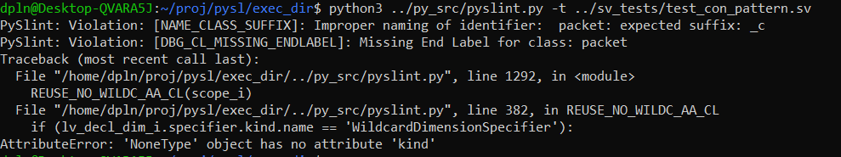

16. Write a constraint to generate a pattern of 000111222333444555…

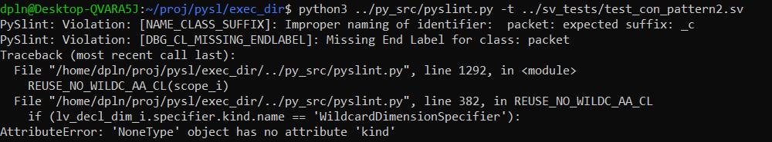

17. Write an SV constraint to make diagonal elements Zero.

